**Cyclistic Bike-Share Case Study (2019 & 2020)**

**Prepared by:** Aryan Farswan  
**Date:** May 3, 2025  
**Tools Used:** Microsoft Excel, Google Sheets.

**1. Introduction**

The goal of this case study is to analyze how Cyclistic bike-share service is used by annual members and casual riders. The objective is to uncover usage patterns and recommend strategies to convert casual users into annual members.

### ****2. Data Overview****

**2019 Dataset:**

* Total Records: 365070
* Columns include: trip_id, start_time, end_time, bikeid, tripduration, from_station_name, to_station_name, usertype, gender, birthyear, ride_length, day_of_week.

**2020 Dataset:**

* Total Records:426770
* Columns include: ride_id, rideable_type, started_at, ended_at, start_station_name, end_station_name, start_lat, start_lng, end_lat, end_lng, member_casual, ride_length, day_of_week.

Datasets were analyzed separately due to format and column differences.

### ****3. Data Cleaning & Preparation****

Performed the following steps in Excel and Power Query:

* Removed missing/invalid values.
* Calculated ride duration (ride_length) using ended_at - started_at.
* Filtered out negative durations.
* Created a new column for day_of_week based on start date.
* Segregated users as member or casual.
* Cleaned station names for consistency.

### ****4. Descriptive Analysis****

**Key Metrics (2019):**

* Total Rides: 365070
* Member Rides: 341906
* Casual Rides: 23163
* Avg. Ride Length (Member): 00:11:30
* Avg. Ride Length (Casual): 00:37:04

**Key Metrics (2020):**

* Total Rides: 426770
* Member Rides: 378407
* Casual Rides: 48363
* Avg. Ride Length (Member): 00:11:34
* Avg. Ride Length (Casual): 00:40:13

Dashboards and charts created for each year separately

### ****5. Key Insights****

* Casual riders take longer rides, especially on weekends.
* Annual members ride more frequently but for shorter durations.
* Weekends see more casual usage; weekdays see more member activity.
* For Members highest ride counts observed on Tuesday, lowest on Saturday.
* For Casuals highest ride counts observed on Sunday, lowest on Thursday.

### ****6. Business Questions Answered****

**1. How do annual members and casual riders use bikes differently?**

* Casuals: Longer rides, weekends.
* Members: Frequent, shorter rides, weekdays.

**2. Why would casual riders buy annual memberships?**

* Incentives for frequent users.
* Time-saving for regular commuters.
* Promotions on weekend rides or bundled offers.

**3. How can Cyclistic use digital media to influence casual riders to become members?**

* Targeted email/social media campaigns.
* Mobile app promotions.
* Highlighting member benefits with ride comparisons.

### ****7. Conclusion****

Based on analysis, we recommend targeting casual weekend riders with offers promoting annual membership benefits, emphasizing cost-saving and convenience. Consistent marketing via digital media can aid conversion.

### ****8. Appendix****

#### 📊 **Visualizations – 2019 Dashboard**

**Figure 1: Total Rides by User Type (2019)**

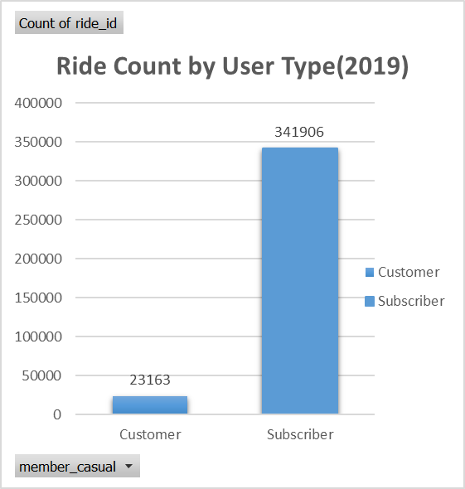

**Figure 2: Average Ride Duration – Members vs Casuals (2019)**  
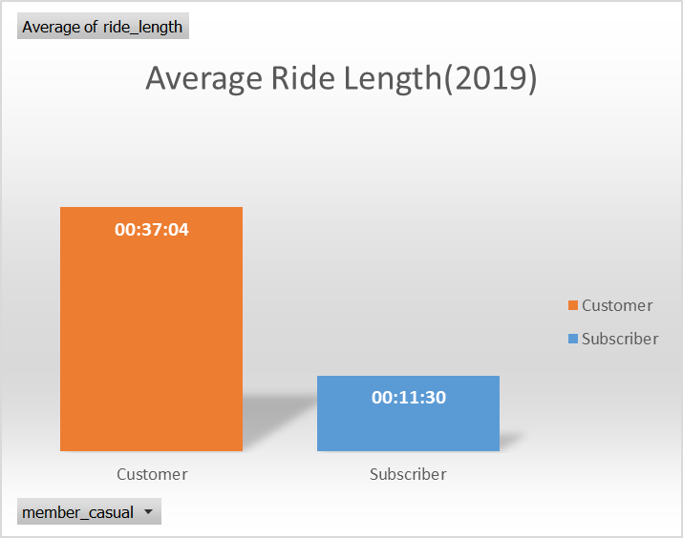

**Figure 3: Weekday Ride Frequency by User Type (2019)**  
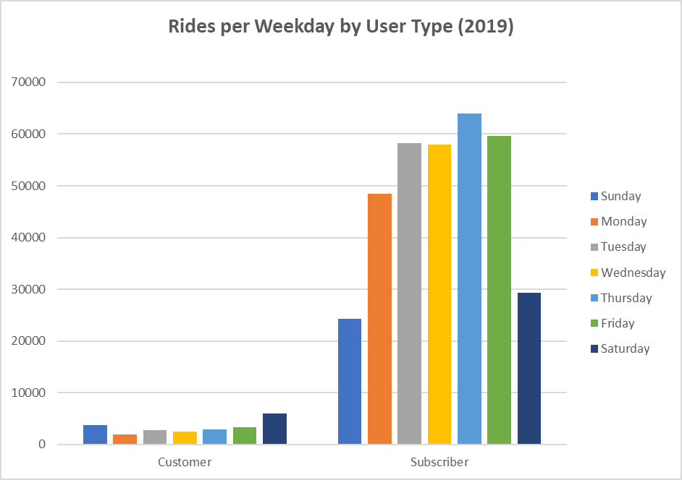

#### 📊 **Visualizations – 2020 Dashboard**

**Figure 4: Total Rides by User Type (2020)**  
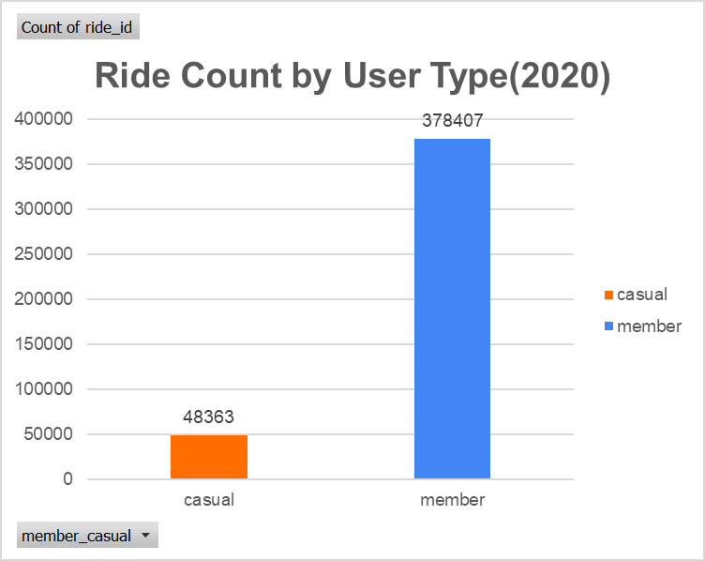

**Figure 5: Average Ride Duration – Members vs Casuals (2020)**  
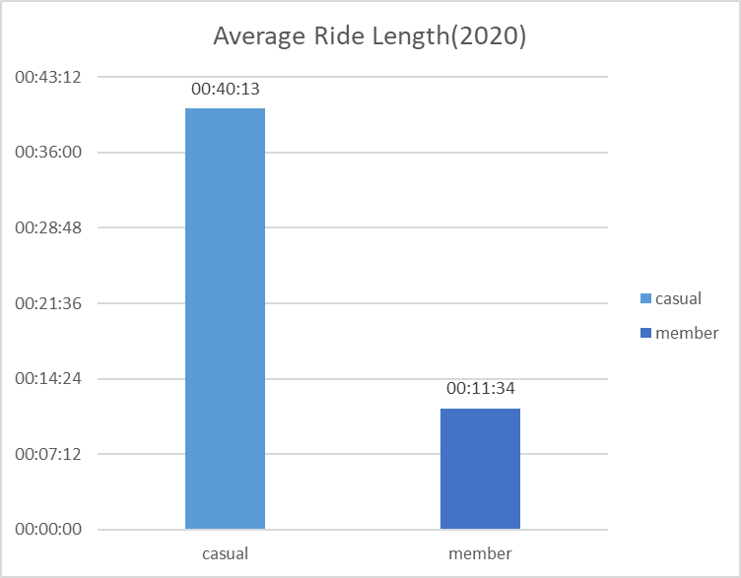

**Figure 6: Weekday Ride Frequency by User Type (2020)**

